NAMES AND STUDENT NUMBER | ST10443781-TEBOGO MABUSELA  ST10445344-DUMISA LUBISA  ST10455770-KAGISO MAPUTLA
GROUP | Group 16
ASSIGNMENT | FINAL(POE)
MODULE | OPEN SOURCE CODE
DATE | 5 NOVEMBER 2026

Table of content
1. Purpose and problem statement 2
2. Design considerations 2
3. Implemented app modules 3
3.1 Login and registration 3
3.2 Home and Discover 4
3.3 Sell, Cart and Settings 5
4. GitHub and GitHub Actions 15
5. Testing, logging and code quality 16
6. Publication readiness 16
7. Release notes — changes since prototype 17
8. Video presentation 17
9. AI tool use declaration (under 500 words) 17
13. References (Harvard style) 18

1. Purpose and problem statement
KasiCrafts is an Android marketplace prototype intended to help South African craft makers display handmade products and help buyers discover locally produced items. It focuses on product visibility, browsing, location-based discovery, and a simple shopping basket. The app is a demonstration project: sample products are labeled, and online checkout or escrow payments are not yet implemented.

2. Design considerations
- User experience: a dark interface with orange accents, prominent product imagery, a search bar, category chips, and bottom navigation.
- Accessibility and localization: English, isiZulu, and Afrikaans resource files; language switching and translation completeness require final testing.
- Technology: Kotlin Android fragments, Firebase Authentication, Cloud Firestore and legacy Realtime Database product retrieval, RecyclerView, Glide for images, and Gradle builds.
- Reliability: clearly labeled sample products provide an immediate demonstration catalog when live data is unavailable; live listings should replace them when retrieved.
- Security: Firebase-managed authentication; seller-upload permissions and production privacy practices must be verified before public release.
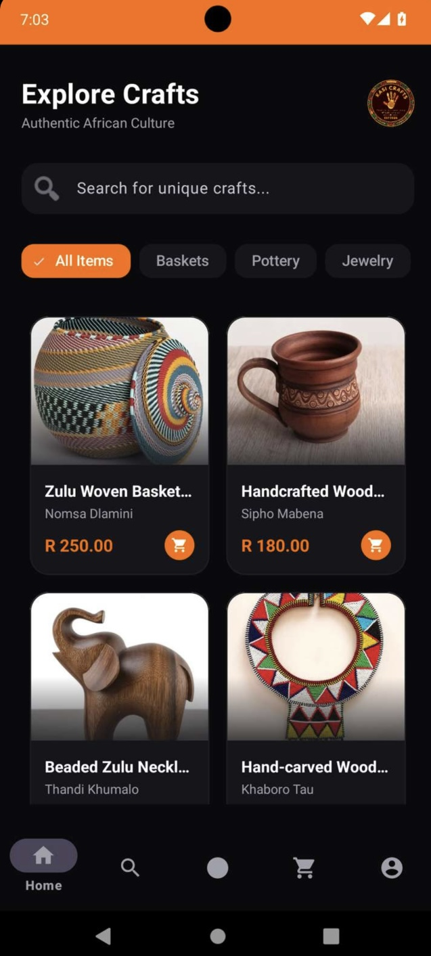
English Home — products and category filters
Captured marketplace demonstration.
Figure: Home marketplace

3. Implemented app modules

3.1 Login and registration
Email/password login and registration are implemented in source code, with email verification logic. A clearly labeled demo browsing option was added for assessment. Google Sign-In requires matching Firebase OAuth configuration and should not be advertised until verified.
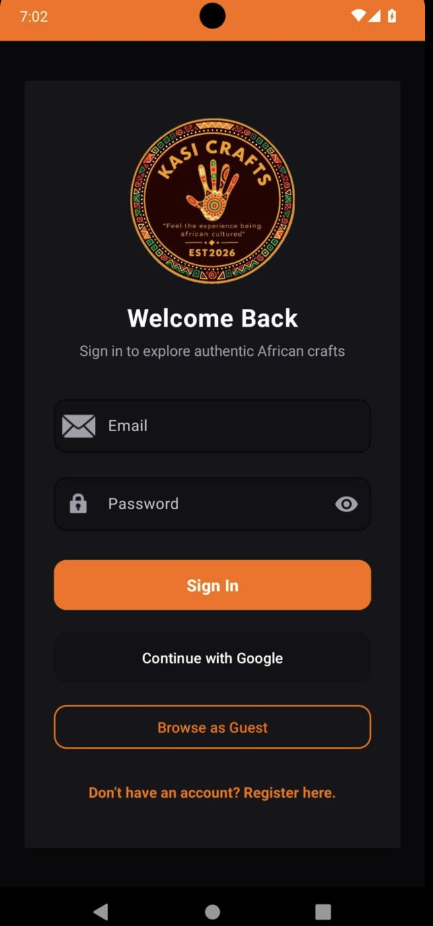
Login and guest access
Authentication screen captured in Appetize.
Figure: Login / demo browsing

3.2 Home and Discover
Home presents a two-column catalog and category chips. Discover presents a vertical listing with product and seller-area search. The repository attempts to load Firebase products and falls back to a labeled set of twelve sample products for demonstration.
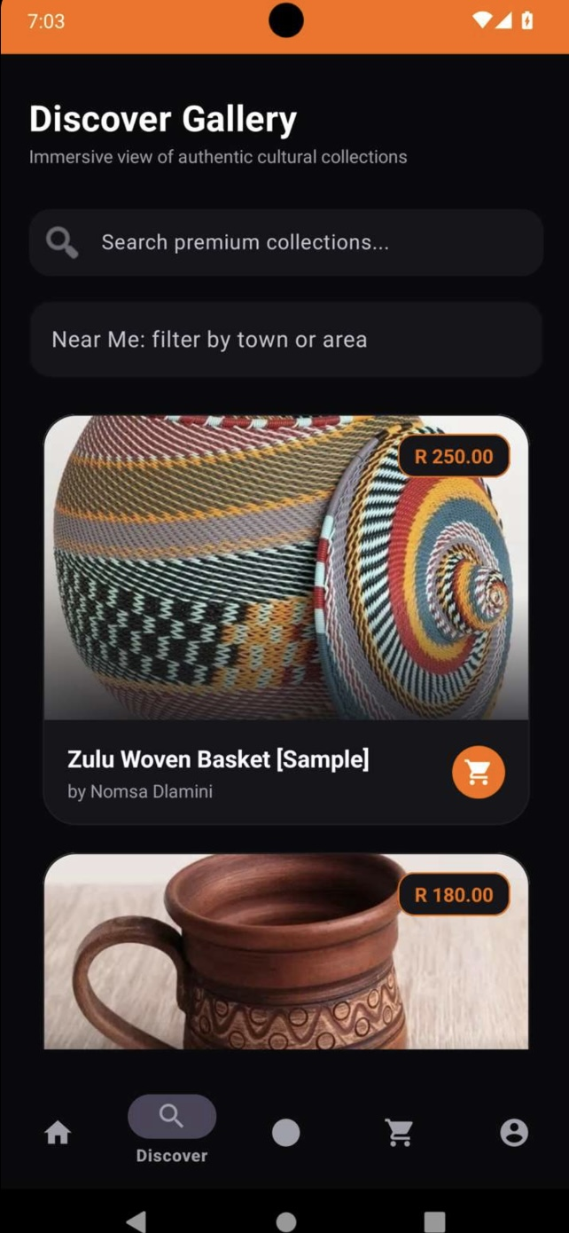
Discover gallery and seller-area filter
Visible search and location-filter controls.
Figure: Discover and search

3.3 Sell, Cart and Settings
The Sell screen provides a product submission interface backed by Firebase code. The basket can add items and calculate totals, but checkout/payment is not available. Settings provides language choices; verify all three languages on-device before claiming full localization.
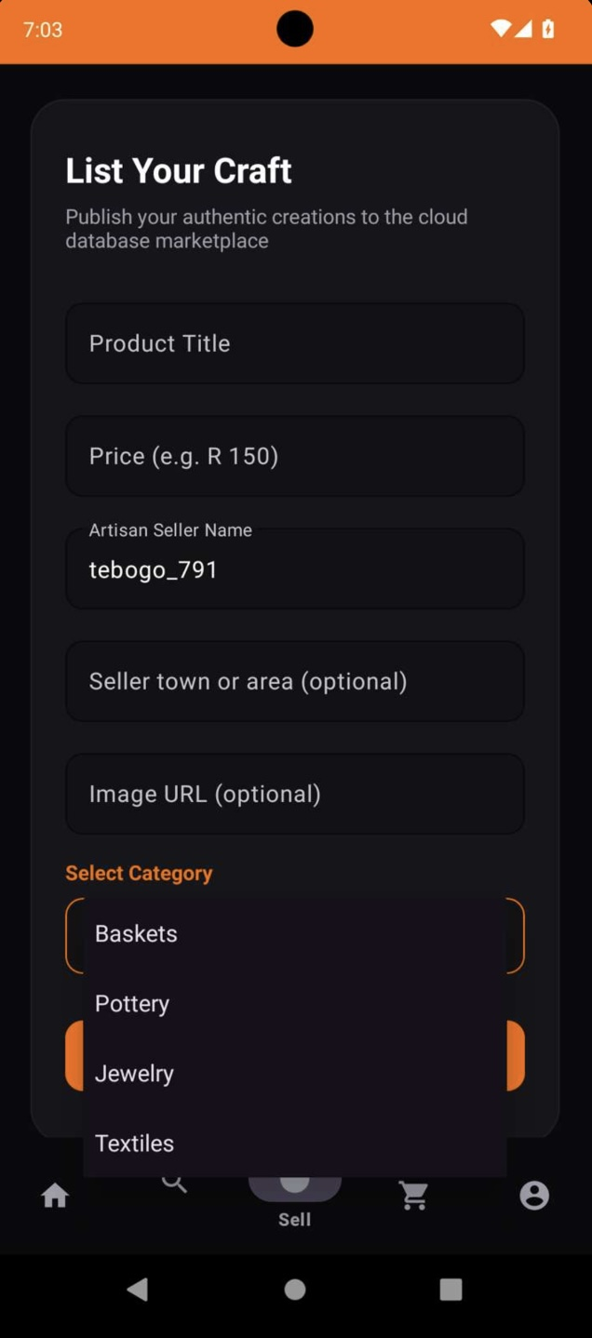
Seller listing form
Product entry fields and category choices.
Figure: Sell product screen
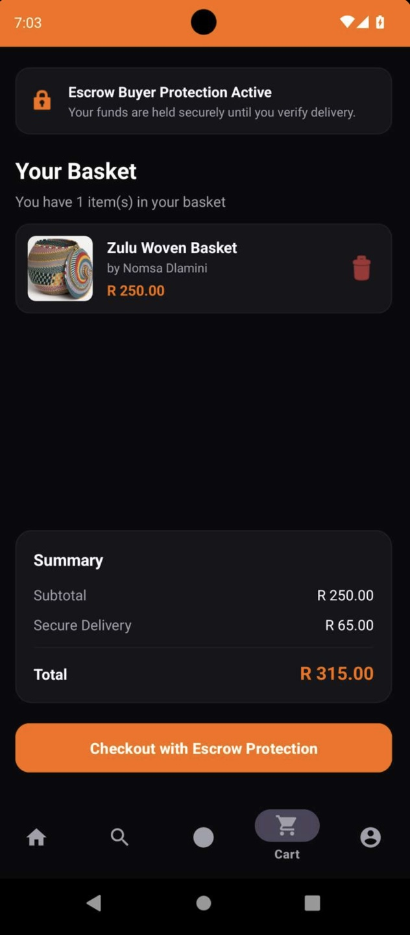
Cart total
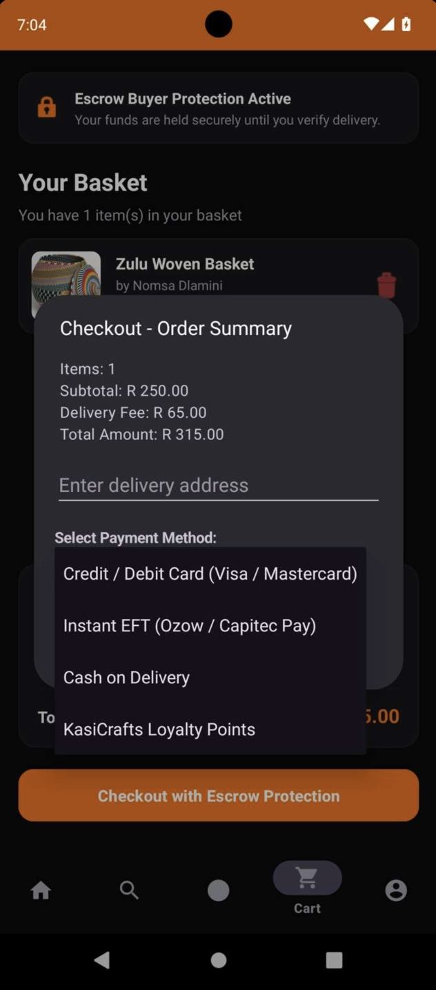
Checkout selection dialog

Figure: Shopping cart
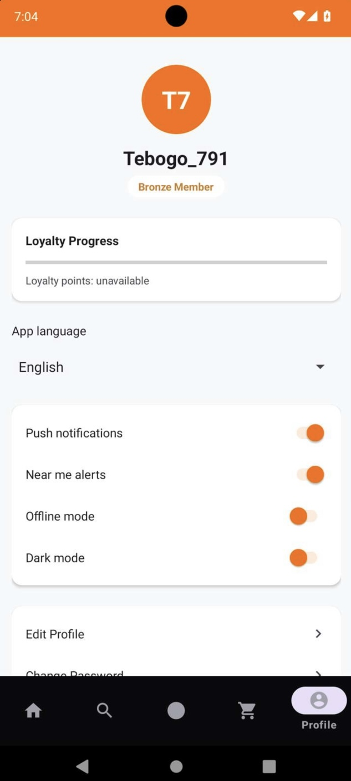
Profile and language selection
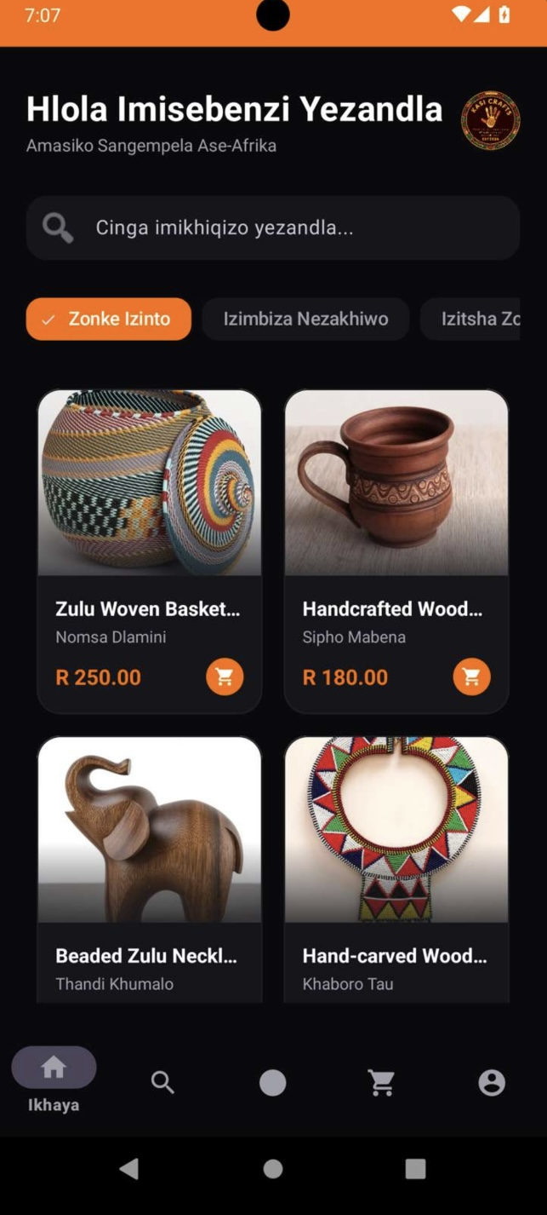
Home translated into isiZulu
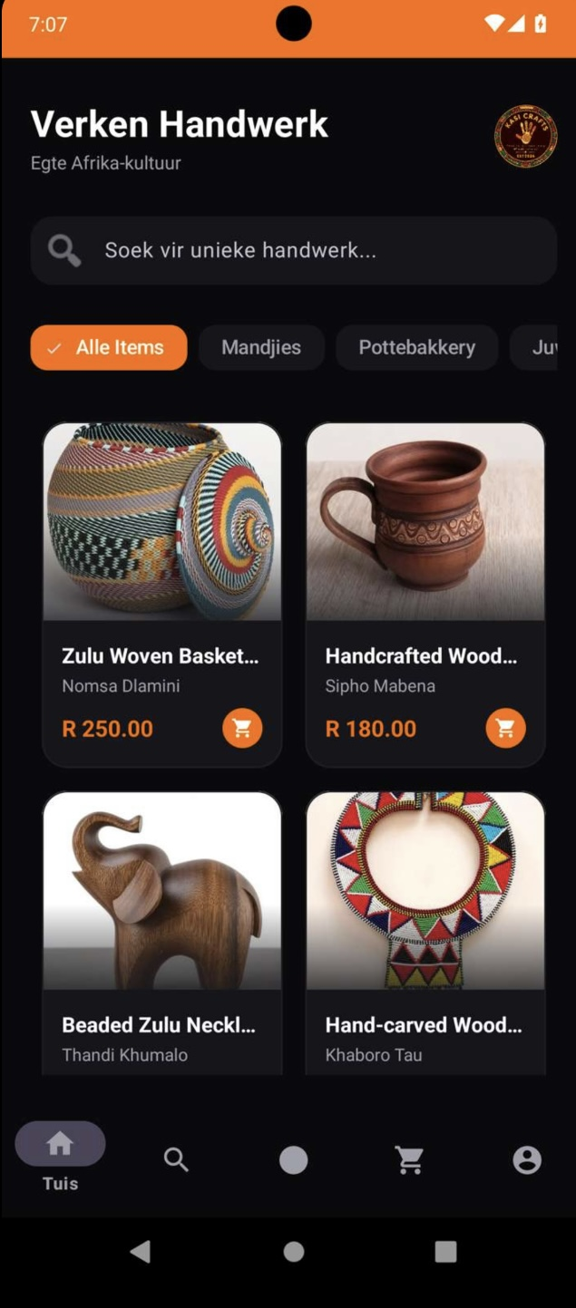
Home translated into Afrikaans
English, isiZulu and Afrikaans Home views documented.
Additional Profile and Settings interface evidence:
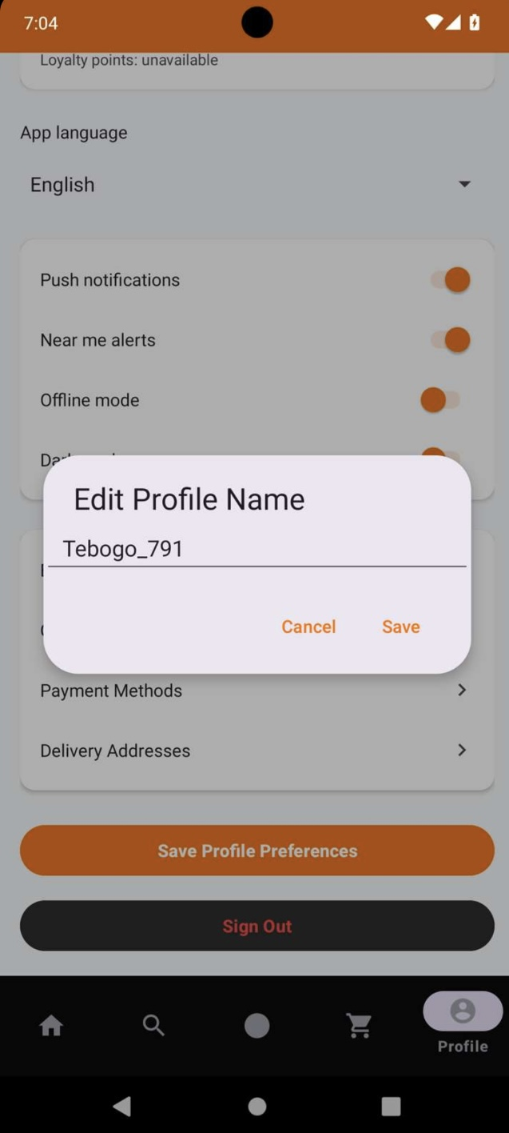
Profile name editing dialog
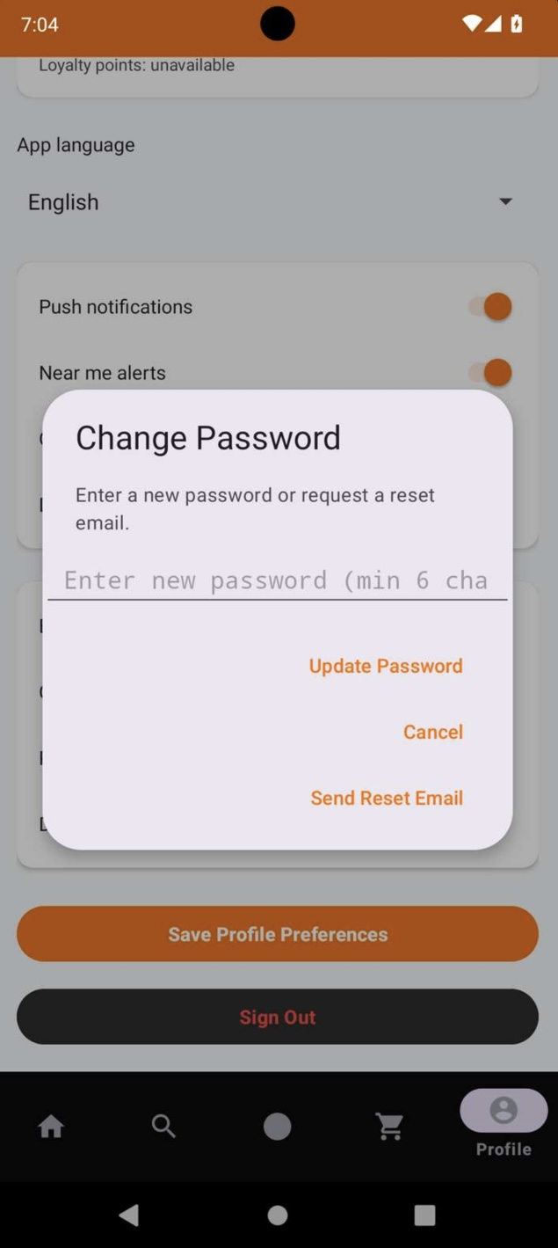
Password update and reset options
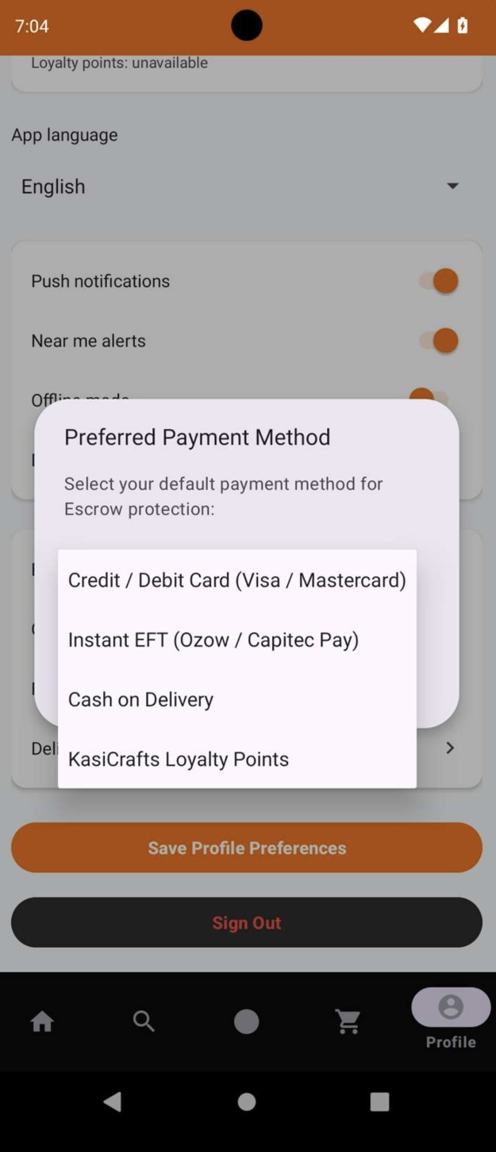
Preferred payment method selection
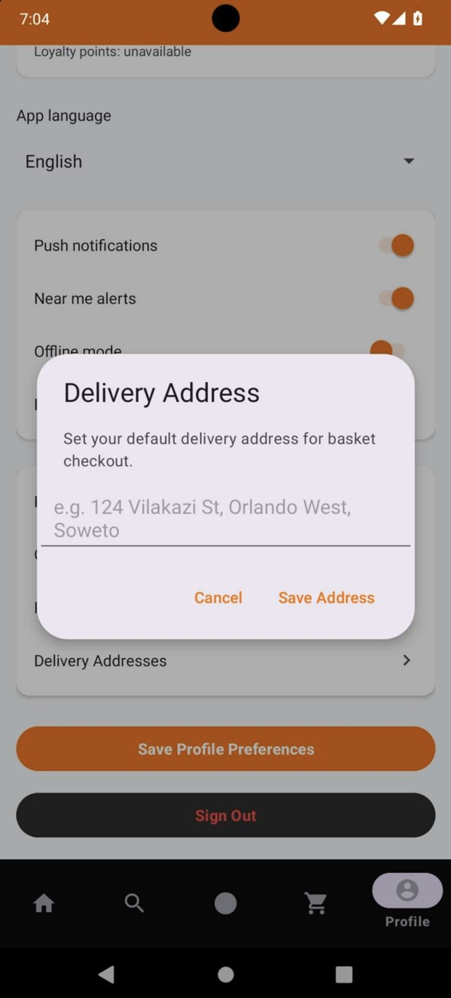
Delivery address form
Figure: Language settings

4. GitHub and GitHub Actions
GitHub hosts the Kotlin source, resources, Gradle configuration, documentation, and version history. Development changes were committed on the fix/marketplace-search-and-upload branch. A GitHub Actions workflow exists at .github/workflows/android-verify.yml to build and run tests automatically. Previous workflow runs encountered Android SDK installation failures; therefore CI success is not yet verified. The latest known local debug APK build completed successfully.
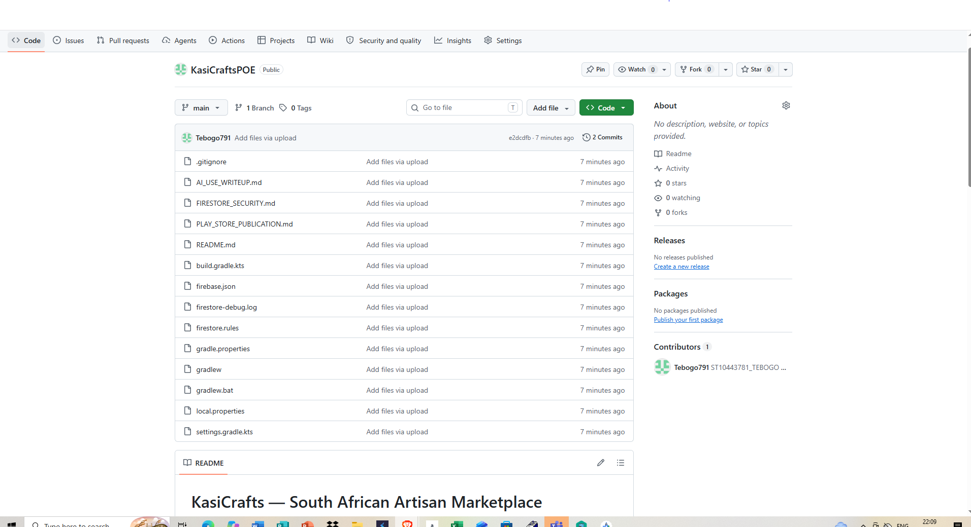
Figure: GitHub repository and source
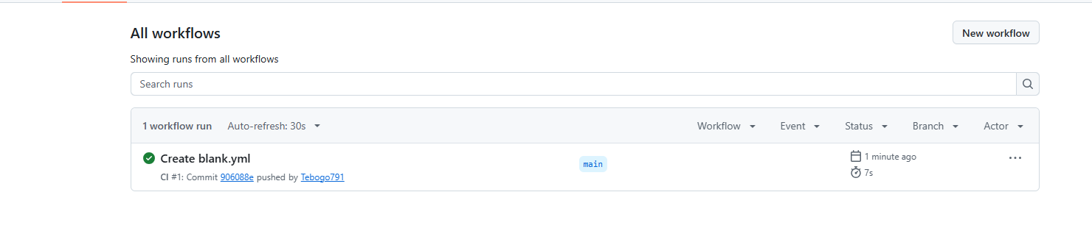
Figure: GitHub Actions workflow and run result

5. Testing, logging and code quality
The project includes application logging for Firebase messaging and login errors, Kotlin code comments, and a JUnit testing setup. For submission, capture a real successful Gradle build and a test result, then review code comments for accuracy and cite any external material used. Avoid claiming comprehensive tests without evidence.
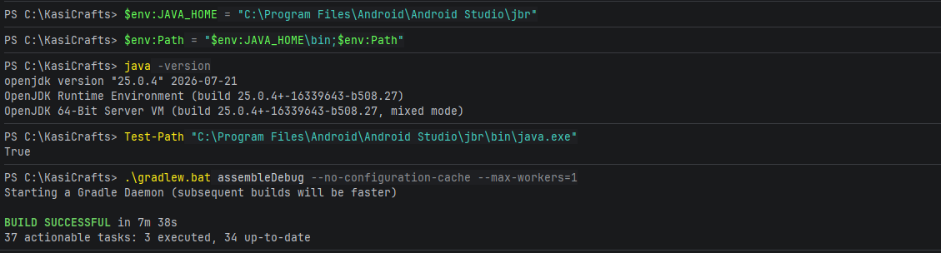
Figure: Successful Gradle build

7. Release notes — changes since prototype
Version 1.0 — assessment demonstration build (release verification pending)
- Expanded product retrieval to Firestore and legacy Realtime Database with alternate field-name support.
- Added twelve clearly labeled sample crafts for demonstration when live products are unavailable.
- Improved Home and Discover search, category browsing and seller-area filtering.
- Added language resources and a language selection interface for English, isiZulu and Afrikaans.
- Added a demo marketplace entry option without requiring Firebase account registration.
- Added a GitHub Actions build/test workflow (currently requires CI troubleshooting).
- Improved shopping-basket presentation while clearly indicating that checkout is unavailable.

8. Video presentation

9. AI tool use declaration (under 500 words)
ChatGPT was used as a development assistant to help review Kotlin source code, suggest Firebase product-loading improvements, draft demonstration catalog data, troubleshoot Gradle and GitHub Actions problems, and structure the project documentation. Suggestions were incorporated into the GitHub project and should be verified through builds and manual testing. AI-generated content does not replace the student’s responsibility to understand, test, and explain the submitted application. Tool: OpenAI ChatGPT (2026), accessed 5 November 2026.

13. References
Android Developers (n.d.) Build your app for release to users. Available at: https://developer.android.com/build/build-for-release (Accessed: 5 November 2026).
Android Developers (n.d.) Sign your app. Available at: https://developer.android.com/studio/publish/app-signing (Accessed: 5 November 2026).
Firebase (n.d.) Firebase documentation. Available at: https://firebase.google.com/docs (Accessed: 5 November 2026).
GitHub Docs (n.d.) GitHub Actions documentation. Available at: https://docs.github.com/en/actions (Accessed: 5 November 2026).
Google Play Console Help (n.d.) Prepare and roll out a release. Available at: https://support.google.com/googleplay/android-developer/answer/9859348 (Accessed: 5 November 2026).
Google Play Console Help (n.d.) Set up an open, closed, or internal test. Available at: https://support.google.com/googleplay/android-developer/answer/9845334 (Accessed: 5 November 2026).
OpenAI (2026) ChatGPT [Large language model]. Used for Kotlin development assistance, troubleshooting and report drafting, 5 November. Available at: https://chatgpt.com/ (Accessed: 5 November 2026).

